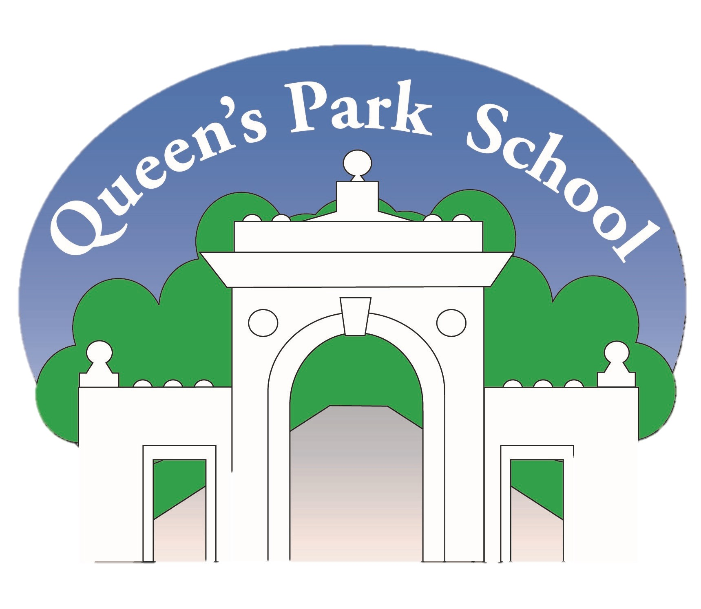 | Summer Term
 | 1 | 2
 | Eco Pioneers | Benin Kingdom
Experiences/Visitors | IntoUniversity Trip | Year 5 Production: ‘A Big Green Adventure’  Sports Day
Language | English  habitats, coastline, grasslands, pollution, ecosystem, estuary, lagoon, marine creature, protect, delicate, offspring, communities, reefs, coral polyps, apex predators, prey overfishing, urchin, mangrove swamps, abundance, vegetarianism, source of protein, especially, nutrients, agriculture, animal welfare, pesticides, balanced, biodiversity, consequences, impact  Reading  Kelp forests, crustaceans, microscopic, algae, krill, plankton, fossil fuels, migration, atmosphere, temperature, youngster, essential, population, stealthy, pod of whales, outmanoeuvre, thrive, spectacle, echolocation, nourishment, savannah, ecological, arid, conserve water, captive, endangered, moisture, roam, wilderness, squadron, brink of extinction, bioluminescent, peril  Maths  generalisation, stem sentence, exchange, regroup, known facts, dividend, divisor, quotient, factor, multi-step, efficient, fraction, equivalent, denominator, numerator, vertical relationship, horizontal relationship, order, compare, convert, preserve, related, unrelated, common denominator, equal parts  Geography  Global warming, environmental, sea levels, temperatures, carbon dioxide, methane, greenhouse gases, emissions, air pollution, detrimental, positive impact, flooding, energy, renewable, solar power, wind power, fossil fuels, vehicles, hybrid, electric, carbon footprint, plastic pollution, re-wilding, sustainability  PSHE  Abuse, Neglect, Sexual, Controlling, Qualities, Motivation, Recovery, Extend  PE  Setting a field, defensive shot, attacking shot, keeping wicket, repetitions, pulse rate, tension, extension, compose, expression, rehearse, gesture, Bangra, Line dance, Choreograph, Locomotor / non locomotor | English  Carbon footprint, global warming, pollution, pollutant, sustainable, fast fashion, drought, floods, disastrous, average, necessary, system, develop, physical, greenhouse gases, global issues, deforestation, electricity, recycled, packaging, landfill, biodegradable, emit, investing, contributes, beneficial / benefits, discard, materials  Reading  Captor, flitting, ancestors, stricken, silhouetted, venturing, remedies, generations, reluctantly, diviner, entranced, chief, ruthless, saunter, plume, thatched roof, compound, burden, procession, impulse,  Maths  generalisation, stem sentence, exchange, regroup, known facts, dividend, divisor, quotient, factor, multi-step, efficient, fraction, equivalent, denominator, numerator, vertical relationship, horizontal relationship, order, compare, convert, preserve, related, unrelated, common denominator, equal parts, angles, acute, straight line, obtuse, reflex  Science  Life cycles, metamorphosis, larva, amphibian, abdomen, exoskeleton, offspring, vertebrate, invertebrate, embryo, pupa, cocoon, nymph, mature, adolescent, mammal, reptile  Computing  microcontroller, USB, connection, output component, motor, Crumble controller, switch, LED, Sparkle, crocodile clips, connect, battery box, Input, output, action, circuit, power, cell, buzzer  PSHE  Abuse, Neglect, Sexual, Controlling, Qualities, Motivation, Recovery, Extend, Menstrual, Reproduction, Self-esteem, Puberty  PE  collaborative, memory, trust, signal, design, decipher, Morse Code, orient,  RE  Ultimate, non-ultimate, creation, diamond nine, belief, opinion, fact, cooperative, converted  Art  Restrict, strategy, pose, manipulation, smocking, ruching, batik, embellish, accentuate, enhance, detract, practicality, aesthetic  Music  Chord, layering, harmony, intervals(3rd/5^{th),} rounds, texture, melody, Unified, Opinion, Unique  improvise, pulse, beat, rhythm, pitch, texture, tempo, semibreve, paired quavers  History  Export, contrast, academic, brass, elders, dynasty, yam, cowrie shell, oracle, oral culture, ivory, slave trade, ceremony, storyteller, merchant
English | Non-chronological report – Coastal Seas  - Structure a text appropriately for the audience and purpose e.g. choice of tense/ choice of person/ choice of formality.  - Use multi-clause sentences effectively.  - Use brackets, dashes or commas consistently to indicate parenthesis  - Use paragraphs to organise ideas and begin to build cohesion within and across paragraphs.  Discussion Text Should humans be allowed to destroy natural habitats for development?  - Structure a text appropriately for the audience and purpose e.g. choice of tense/ choice of person/ choice of formality.  - Adverbials for contrast, cause and effect and meaning  - Organise the content of my writing (Point Evidence Elaborate) within paragraphs. | Narrative – Children of the Benin Kingdom  - Structure a text appropriately for the audience and purpose e.g. choice of tense/ choice of person/ choice of formality.  - Describe settings, character and atmosphere with an increasing awareness of the reader and begin to include dialogue that conveys character to advance the action.  - Describe characters, settings and create atmosphere by using adverbials, expanded noun phrases and figurative language e.g. simile, metaphor, personification across a range of genres.
Reading | Our Planet – David Attenborough | Children of the Benin Kingdom by Dinah Orji
Maths | - Different calculating strategies for multiplication and division  - Word/contextual problems and multi-step problems  - Order and comparing fractions  - Converting fractions from mixed number to improper  - Adding and subtracting fractions with different denominators  - Working with equivalent fractions | - Working with equivalent fractions  - Classifying angles  - Understanding turns  - Calculating angles  - Measuring angles  - Drawing angles  - Reasoning about angles in polygons
Science |  | Animals including humans  Big Question: How do different animals grow and change throughout their lives?  Knowledge:  - describe the changes as humans develop to old age (birth, infant, toddler, adolescent, adult, elderly)  - I know the differences in the life cycles of a mammal, an amphibian, an insect and a bird  - I know the life process of reproduction in some animals (humans)  Skills:  - Researching the gestation periods of other animals and comparing them with humans  - By finding out and recording, on a graph, the length and mass of a baby as it grows  - Researching and recording, on a graph, the life spans of different animals
History |  | Big Question: What does trade mean and how was this developed in the Benin Kingdom?  Discovering a non- European society that contrasts with British history – Benin Civilization  Knowledge:  - To understand different technological, scientific, cultural, and aesthetic achievements of groups of peoples in a particular society or in the wider world, along with some of the social, political, religious, and economic systems from the past, and be able to make links and comparisons.  - To be able to listen to others’ findings and form their own thoughts on varied sources’ impact and significance, so that they can respond to their peers.  Skills:  - I can identify where the Kingdom of Benin was and what time period it was in.  - I can discuss the trade networks of the Benin Kingdom.  - I can explain achievements from the Benin Empire’s Golden Age.  - I can look at evidence available and begin to evaluate the usefulness of different sources – understand the prevalence of white/privileged people’s history and the erasure of black history before colonisation.  - I can discern how and why contrasting arguments and interpretations of the past have been constructed.
Geography | Big question: What is sustainability and why is it important?  Knowledge:  - I know that humans can have both a positive and negative impact on the natural world.  Skills:  - I can describe and understand key aspects of human geography such as the distribution of natural resources including energy, food, minerals and water.  - I can identify and explain changes to the world environment.  - I can understand why people seek to manage and sustain their environment.
Art / DT |  | Big Question: Why are women’s voices important in Art?  Textiles  Artist – Faith Ringgold  Influence on Feminist movement and social activism  Knowledge:  - Understand how fabrics can be strengthened, stiffened and reinforced where appropriate.  - Know and use technical vocabulary relevant to the project.  - To know that different stitch patterns can be used to create different effects  - To know that media can be layered and overlapped to create different effects  - To know that different materials to create mood  - To know there are different grades of threads and needles.  Skills:  - Produce a 3-D textile product from a combination of accurately made fabric shapes and different fabrics.  - Use fabrics to create 3D structures.  - To develop decorative prints and paint effects on fabrics  - To use variety of techniques to create different textural effects, e.g. printing, stitching, dyeing  - To use sketchbooks to collect and record visual information from different sources.  - To record textile explorations and experimentations as well as try out ideas  Moving on to:  - To be able to explore techniques to create an image or artefacts and decorate  - To experiment with a variety of techniques.  - To use a number of different stitches creatively to produce different patterns and textures.
Computing |  | Big question: How do you programme a microcontroller?  Knowledge:  - I know how to select in physical computing  - I know how to select using a programmable microcontroller.  Skills:  - I can design, write and debug programs that accomplish specific goals, including controlling or simulating physical systems; solve problems by decomposing them into smaller parts.  - I can use sequence, selection, and repetition in programs; work with variables and various forms of input and output.  - I can use logical reasoning to explain how some simple algorithms work and to detect and correct errors in algorithms and programs.  - I can select, use and combine a variety of software (including internet services) on a range of digital devices to design and create a range of programs, systems and content that accomplish given goals, including collecting, analysing, evaluating and presenting data and information integrate.  - I understand microcontroller, USB, connection, output component, motor, Crumble controller, switch, LED, Sparkle, crocodile clips, connect, battery box, Input, output, action, circuit, power, cell, buzzer
PSHE/RSE | Big Question: Who are Gypsy, Roma Traveller People and what do we have in common?  Knowledge:  - All different all equal  - There are many different groups of Gypsy, Roma and Traveller people.  - Some Traveller people live in caravans or trailers on official sites or beside the road if they can’t find a good stopping place.  - Some Traveller people also live in houses.  - Some Traveller people travel for the summer with a fair or circus.  - Everyone has the right to feel safe all of the time.  - Everyone is welcome.  - Prejudice: Incorrect or untrue thinking about a person just because they belong to a certain group.  - Discrimination: Negative behaviour or actions towards a person or group because they belong to a certain group.  - Challenge prejudice and discrimination.  Skills:  - I can tell you how we are similar and different to each other.  - I can tell you what is the same about my home and the home of a Gypsy, Roma or Traveller child.  - I can tell you who Gypsy, Roma or Traveller people are.  - I can tell you about prejudice and discrimination and how it effects Gypsy Roma Traveller children and young people.  - I can tell you about the art and culture in Gypsy Roma Traveller heritage.  - I can tell you how to welcome someone into class and what to do if I notice someone being mean to a new person because of their family and heritage.  Big Question: How does my behaviour and language have an impact on others?  Knowledge:  - Everyone has the right to feel safe all of the time.  - Nothing is too small or awful to talk about it.  - Body confidence  - Early warning signs  - Safety continuum  - Safe and unsafe touch  - Safety network  Skills:  - I can tell you that I have a right to feel safe.  - I can say when I feel safe and unsafe.  - I can tell you about words and phrases that feel safe to use.  - I can name the private and personal parts of the body.  - I can describe my early warning signs.  - I can tell you what fun to feel scared and risking on purpose means and give you some examples.  - I can tell you what I can do if something does not feel fun to feel scared anymore.  - I can begin to tell you about the importance of choice, control and time limit in making safer choices.  - I can tell you about different types of abuse (emotional, physical and sexual).  - I can ask for help.  - I can tell you about the qualities of someone who can help. | Big Question: What is puberty?  Knowledge:  - Coping with embarrassment.  - Normalise growth and change.  - Learning about how most girls’ and most boys’ bodies change at puberty will help us to build our knowledge about ourselves and help to keep us safe.  - Personal and private does not mean secret or rude.  - Promote body confidence and safety via confident use of scientific names for the personal and private parts of the body.  - Correct use of vulva  - Safety messages:  - These are the parts of your body under your pants.  - They are important personal and private.  - They belong to you.  - Usually only you, your family or a doctor or nurse might see them.  - Remind children that although they will grow and change, they are all special and unique.  - Normalise impact of puberty on feelings  - Coping strategies  - Hygiene is important for keeping healthy and safe during puberty.  Skills:  - I can clarify the feeling of embarrassment and give examples.  - I can tell you what I can do if I feel embarrassed.  - I can tell you how children grow and change.  - I can tell you what is the same and different between most girls’ and most boys’ bodies.  - I can name and tell you about the function of the private and personal parts of the body.  - I can tell you how to keep my personal and private parts of the body safe.  - I can tell you that bodies come in all shapes and sizes.  - I can tell you what I could say or do If I notice someone being mean about someone else’s body.  - I can tell you what happens at puberty for most girls and most boys.  - I can tell you what a menstrual period is.  - I can tell you that a menstrual period is normal, a sign of health and something to celebrate and be proud of.  - I can make a link between puberty and human reproduction.  - I can tell you about wet dreams and how to cope with them.  - I can tell you how puberty might affect someone’s feelings.  - I can tell you what to safely do if someone is mean about how someone’s body is changing.  - I can tell you how young people can look after themselves during puberty.  Big Question: What can I do to improve my confidence?  Knowledge:  - Common responses to change, feeling insecure and unconfident, recognising our ‘sore spots’.  Skills:  - I can tell you how changes can make me feel.  - I can tell you some ways to manage change.  Big Question: What goals can I set myself to extend my learning in Year 6 and beyond?  Knowledge:  - Knowing the skills of a good learner and identifying areas for development in myself  Skills:  - I can set learning goals to challenge and extend my learning in Year 6.  Big Question: What is CPR?  Knowledge:  - St John’s Ambulance pathway. Bleeding.  Skills:  - I understand basic life support e.g. CPR recovery position.
Music | Big Question: How can I change the effect of my music? (link to Let’s Play)  Knowledge:  - To understand that varying effects can be created, for example by changing the pitch, dynamic or tempo of the sounds made.  Skills:  - Listening  - I can begin to describe, compare and evaluate music using musical vocabulary  - Singing and playing  - I can begin to breathe in the correct place when singing  - Composing  - I can create short rhythmic phrases and teach them to my friends  - Performing  - I can evaluate my playing and say how I can improve it  - Transcribing and using symbols  - I can recognise the differences between semibreves, minims, crotchets and crotchet rests, paired quavers and semiquavers | Big Question: What is it called when notes are played together?  Knowledge:  - To understand that a chord is the layering of several pitches played at the same time.  Skills:  - Listening  I can explain why they think their music is successful or unsuccessful  - Singing and playing  I can recognise and use basic structural forms such as rounds/ call response  - Composing  To use groups of pitches (chords)in their compositions  - Performing  I can maintain playing my part whilst others are performing another part  - Transcribing and using symbols  - MELODY  Begin to look at harmony (intervals of 3rd/5th)
RE |  | Big question: What are ultimate questions and how can religion and science help us understand these?  Knowledge:  - To be able to identify what a non-ultimate and ultimate question is.  - To be able to ask questions and suggest answers about ultimate questions.  - To be able to reflect on the ultimate question ‘How did the world begin?’ To suggest answers and know that different religions answer this question very differently.  - To be able to compare the genesis creation story and one from another culture and give their viewpoint.  - To compare the Hindu creation story with the Muslim creation story. To be able to explain any similarities and differences.  - To discuss what science says about how the world began.  - To create a range of non-ultimate questions under different headings and discuss possible answers.  Skills:  - I can describe and explain with some detail important beliefs and concepts and show an appreciation for differences in religions  - I can explain my own beliefs and views and the similarities and differences between these and the religions we have studied  - I can explain how teachings, stories and texts inform how religious people choose to live their lives
PE and Sport | Cricket  Big Question: What are the basic rules of cricket?  Knowledge:  - How to work with a partner to score runs  - How to throw for accuracy over short distances  - How to position body when running in to bowl the ball  - How to defend the wicket (and not necessarily score a run)  - How to position the fielders to prevent runs being scored  Skills:  - Working with a partner to score / call runs  - Throwing for accuracy over short distances  - Keeping wicket / following the path of ball  - Overarm bowling with a run up  - Playing a forward defensive shot  - Setting a field in a game situation  Dance  Big Question: How can I use different dance styles to create a seascape?  Knowledge:  - How to perform a locomotor and non-locomotor movements  - How to create group patterns  - How to use simple line dance routines  - How to work collaboratively within a group to improve our dance  Skills:  - I can use non locomotor movements such as bending, swaying or wiggling  - I can adapt a pair dance into a group dance  - I can link jumping, travelling, turning, gesturing and stillness in a dance routine | Athletics  Big Question: What do we need to do to perform well as a relay team?  Knowledge:  - How to pass a baton safely in relay running  - How to use body position to throw an object  - How to use body position for jumping  - How to give feedback to others in a group  Skills:  - Running as a part of a relay team  - Developing the principle of pace  - Jumping for distance  - Push throw  - Baton exchange within a restricted area  - Teaching the STEP principle to another group  OAA  Big Question: How can I improve my communication with a partner during a challenge?  Knowledge:  - How to send and interpret messages using Morse Code  - How to use clear communication to recreate a shape from memory  - How to use imagination and creative thinking to create the tallest marshmallow tower  - to use memory methods to recall different objects whilst navigating.  Skills:  - To explore different ways of communicating with a blindfolded partner  - To recall different objects while navigating  - To work collaboratively
Spanish |  | En la cafetería  At the Café  - I will learn 10 different foods, snacks and drinks in Spanish with the correct indefinite article/determiner.  - I will learn another 10 different foods, snacks and drinks in Spanish with the correct indefinite article/determiner.  - I will learn some key phrases to help me perform a role-play in the Spanish cafetería. unas paellas some paellas  - I will learn some more key phrases to help me perform a role-play in the Spanish cafetería.  - I will learn about Spanish currency and will use my knowledge of numbers to help calculate the bill in Spanish

