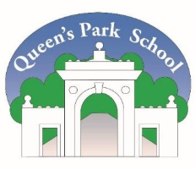

Queen’s Park Mission Statement
Bravely navigate a changing world—with curiosity, confidence, and joy.
Queen’s Park Vision
Our children love coming to school. They experience success through strong, trusting relationships, a deep sense of belonging, positive connections with others, and the courage to challenge themselves.
We celebrate the strength of our diverse community. We create a safe, welcoming environment where every child is seen, heard, and truly valued. Learning is exciting and challenging, with plenty of opportunities to explore new ideas, aim high, and discover individual talents.
We encourage children to ask big questions, stand up for what they believe, and understand different perspectives.
Together with families, we help children develop the knowledge, skills, and character they need to thrive in a changing world. We want every child to feel proud of who they are—and brave enough to shape a better future.
Queen’s Park Values
Kindness - Integrity - Excellence - Collaboration
Equalities Policy
Date | March 2023
Review Date | March 2027

Compliance

This policy has been written with reference to the following guidance and documents:
- Equality Act 2010
- Equality Act 2010: advice for schools DfE Feb 2013
- Equality Act 2010 (Specific Duties and Public Authorities) Regulations 2017
- UN Convention on the Rights of the Child (1989)
- SEND Code of Practice (September 2014)
- Schools information Report Regulations (2014)
- Statutory Guidance on Supporting pupils at school with medical conditions (April 2014)

Details of how our school is complying with the public sector equality duty will be reviewed and updated annually. Our equality objectives will be reviewed and updated at least once every 4 years.

Equalities Statement
Aims and objectives

At Queen’s Park Primary School, our vison and values promote inclusion, equity and equality for all pupils, staff, parents and carers. We champion the Equality Act 2010 to ensure that there will be no discrimination against any individual or group, regardless of faith, ethnicity, disability, gender, sexual orientation, political or financial status, or similar. Our school embraces the aim of working together with others to improve children’s educational and wellbeing outcomes, and notes the rights set out in the UN Convention on the Rights of the Child.

We tackle discrimination through the positive promotion of equality in our curriculum and teaching and learning practices; by challenging bullying and stereotypes and by creating an environment, which celebrates diversity.

We all have equal rights but we have different needs and we recognise that to provide for these, we need to ensure equality of opportunity for all pupils. We aim to build on our similarities and to seek enrichment from our differences and so promote understanding and learning between and towards others to create a cohesive community.

The Equality Act 2010 requires schools to publish information to show how we are working to:
- Eliminate discrimination
- Advance equality of opportunity between people who share a protected characteristic* and people who do not share it
- Foster good relations between groups of people

*Protected characteristic is the term used in the Equality Act to describe a range of different groups, including:
- Disabled pupils and those with special educational needs
- Gender, including gender reassignment and transgender pupils
- Minority ethnic pupils
- Pupils for whom English is an additional language
- Sexual orientation
- Gypsy, Roma and Traveller children
- Religion or belief

In addition to these groups, we believe it is vital to consider the specific needs of other vulnerable pupils such as those who are looked after; children from refugee families; those who have a carer’s role and children eligible for pupil premium (PP) funding.

How will we achieve these objectives?

To foster good relations between groups of people we will:
- drive the development of greater empathy within our school of people with different ethnicity, gender faith, disability, gender, sexual orientation, political or financial status, or similar
- ensure that the curriculum reflects and represents a diverse range of genders, disabilities religious and ethnic communities, celebrating a range of festivals as appropriate
- challenge any incidence of name calling or any other form of harassment or bullying based on outward appearance or equality characteristics
- Make every effort to ensure governors are representative of the community
- provide a fair access to clubs through prioritising groups and making funds available
- embed the language and strategies of ‘emotion coaching’ across the school so that all pupils have shared strategies and language for resolving conflicts peacefully
- establish a playground buddy system to foster relationships between various groups of pupils
- raise money for different charities throughout the school year to ensure a greater understanding of the world in which we live and the challenges faced by many

To advance equality of opportunity between people who share a protected characteristic* and people who do not share it we will:
- use the evolving curriculum to ensure every learner is represented, fully engaged in their learning, experiences success and ensures achievement
- track different groups of children and identify gaps and look at how we can close them through school development plans and pupil progress meetings
- ensure all Pupil Premium (PP) children are closing the gap in Reading, Writing and Maths between non-PP children
- Consider needs not labels to ensure forensic assessment drives decisions to address potential barriers to school life rather than assumptions
- ensure that children who are in receipt of Pupil Premium are able to access school trips and clubs through access to extra funding
- create Individual Health Care Plans for children with medical needs
- create Personal Emergency Evacuation Plans (PEEPS) where required for children with disabilities
- continue to improve the physical environment of our school to enable disabled pupils to take better advantage of education, benefits, facilities and services provided
- increase the extent to which disabled pupils can participate in the curriculum
- ensure all SEND children make good or better progress across the year
- develop further ways in which to ensure pupils with EHCPs fulfil their potential
- ensure all children, who have English as an additional language, are fully supported and make good or better progress across the year
- work with families to ensure we can support the needs of their children, e.g. supporting young carers
To eliminate discrimination, we will:
- further develop ways of seeking out and acting upon the views of black and minority ethnic parents/carers on ways in which access to school information and their participation in school life can be improved
- monitor the participation in clubs, school activities, parent’s evenings of PP children and their parents
- have clear guidelines on how to record bullying
- have worry boxes so that children can speak to trusted adults if they are worried about something
- have a governor who leads on equalities in school
Contextual data for Queen’s Park Primary School

Our school community is made up of a wide range of families and below is a summary of our census data showing the range of differing groups we have in the school:
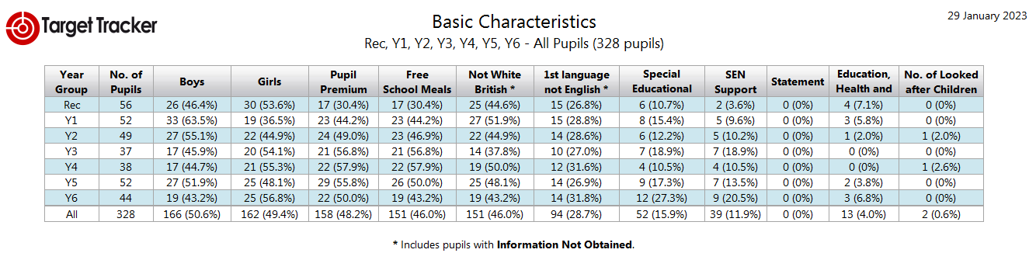

Ethnic Group | % of pupils
White British | 54%
Any Other Mixed Background | 3%
Kurdish | Less than 3%
Bangladeshi | Less than 3%
Other Ethnic Group | Less than 3%
White and Black African | Less than 3%
Arab Other | 3%
White Other | 6.4%
Any Other Asian Background | 4.6%
Black – African | 3%
Indian | Less than 3%
White – Irish | Less than 3%
White Eastern European | 4%
White Western European | Less than 3%
White and black Caribbean | Less than 3%
Refused | Less than 3%
Gypsy/Roma | Less than 3%
White and Asian | 3.4%
Iranian | Less than 3%
Black Caribbean | Less than 3%
Any Other Black Background | Less than 3%
Chinese | Less than 3%

Complaints
We urge parents/carers with any concerns regarding the Equalities policy or the steps we are taking at Queen’s Park to meet the equality objectives to speak to us as soon as possible. In the first instance, please speak to the class teacher. If parents/carers feel they still have a concern, they should make an appointment to speak with a member of the SLT.

